**PROJECT CALCULATIONS**

**12413 Safiullah Rehmani**

**12113 Shahmeer Khan**

**12452 Shaheer Shakeel**

Equation of Ellipse (path of asteroid):

(x - 25,000)^2 + (y)^2 = 1 **------------------------------------------- 1st equation**

(25,000)^2 (20,000)^2

Linear Equation (path of rocket):

y = 1.7321x – 17,321 **------------------------------------------- 2nd equation**

* Putting equation 2 in equation 1:

(x - 25,000)^2 + (y)^2 = 1

(25,000)^2 (20,000)^2

(x - 25,000)^2 + (1.7321x – 17,321)^2 = 1

625,000,000 400,000,000

(x^2 - 50,000x + 625,000,000) + (3.000170x^2 – 34,642x + 300,017,041) = 1

625,000,000 400,000,000

16(x^2 - 50,000x + 625,000,000) + 25(3.000170x^2 – 34,642x + 300,017,041) = 1

10,000,000,000

(16x^2 - 800,000x + 10,000,000,000) + (75.00425x^2 – 866,050x + 7,500,426,025) = 1

10,000,000,000

91.00425x^2 – 1,666,050x + 17,500,426,025 = 10,000,000,000 **---------- ref 1**

* Subtract 10,000,000,000 from both sides8

91.00425x^2 – 1,666,050x + 17,500,426,025 – 10,000,000,000 = 10,000,000,000 – 10,000,000,000

91.00425x^2 – 1,666,050x + 7,500,426,025 = 0

* Use quadratic formula with a = 91.00425, b = -1,666,050, c = 7,500,426,025

_______

* x = −b ± √b^2−4ac

|  |  |
| --- | --- |
| −(−1,666,050) ± √(−1,666,050)^2 − 4(91.00425)(7,500,426,02) | |
| 2(91.00425) | |

2a

x =

|  |  |
| --- | --- |
| 1,666,050 ± √45,440,022,157.575195 | |
| 182.0085 | |

x =

x2 = 1,666,050 − 213,166.6535 a

182.0085

x2 = 1,452,883.3465 y

182.0085

x2 = 7,982.502721

x1 = 1,666,050 + 213,166.6535 a

182.0085

x1 = 1,879,216.6535 y

182.0085

x1 = 10,324.884021

* Now putting values of x1 and x2 in 2nd equation:

y = 1.7321x – 17,321

y2 = 1.7321(x2) – 17,321

y2 = 1.7321(7,982.502721) – 17,321

y2 = 13,826.49296 – 17,321

y2 = –3494.50704

y1 = 1.7321(x1) – 17,321

y1 = 1.7321(10,324.884021) – 17,321

y1 = 17,883.73161 – 17,321

y1 = 562.73161

* Thus **points of Intersection** between both equations are:

**(x1, y1) = (10,324.884021, 562.73161)**

**(x2, y2) = (7,982.502721, –3494.50704)**

**Reference 1**

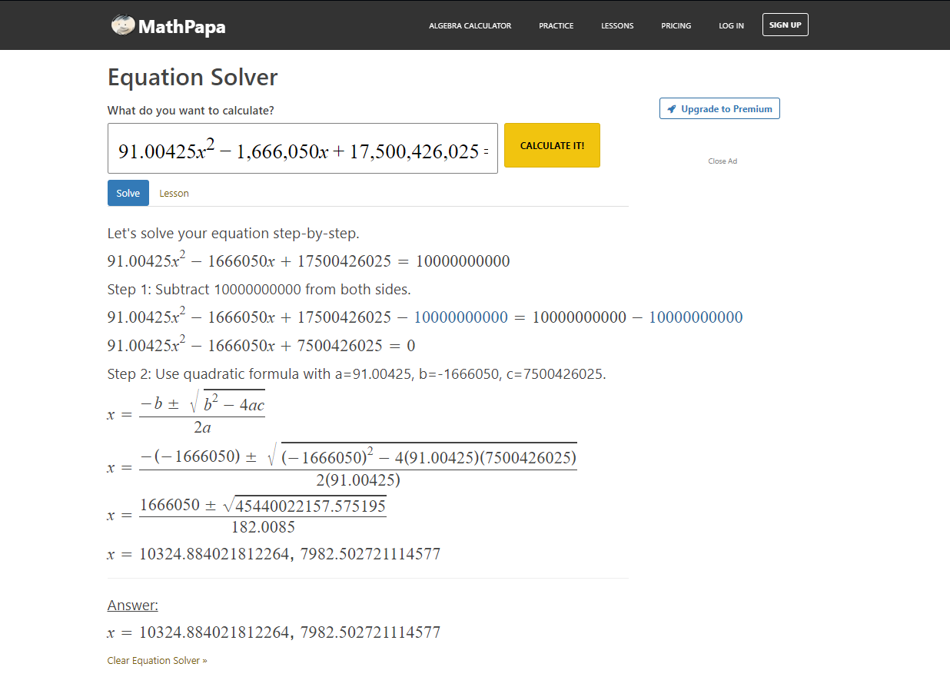

**Rough Work 1**

(x - 25,000)^2 + (y)^2 = 1

(25,000)^2 (20,000)^2

(x - 25,000)^2 + (y)^2 = 1

625,000,000 400,000,000

16(x^2 - 50,000x + 625,000,000) + 25(y^2) = 1

10,000,000,000

16x^2 - 800,000x + 10,000,000,000 + 25x^2 = 10,000,000,000

25y^2 = 10,000,000,000 - 16x^2 + 800,000x - 10,000,000,000

√25y^2 = √-16x^2 + 800,000x

5y = 4x + √800,000x

y = 4x + √800,000x

5

* Putting this value in equation 2

4x + √800,000x = 1.7321x – 17,321

5

4x + √800,000x = 5(1.7321x – 17,321)

4x + √800,000x = 8.6605x – 86,605

8.6605x – 4x – 86,605 – √800,000x = 0

4.6605x – 894.427191(x^1/2) = 86,605

4.6605x – 894.427191(x^1/2) = 86,605

x = 36,869.12737

16(36,869.12737 - 25,000)^2 + 25(y)^2 = 1

10,000,000,000

2,254,018,952 + 25y^2 = 10,000,000,000

25y^2 = 10,000,000,000 - 2,254,018,952

y^2 = 7,745,981,048

y = 88,011.25523

**Rough Work 2**

(x - 25,000)^2 + (y)^2 = 1

(25,000)^2 (20,000)^2

* Parametric Equations of x and y will be,

**x = 25,000 + 25,000(cosθ) ------------------------------------------- 3rd equation**

**y = 20,000(sinθ) ------------------------------------------- 4th equation**

* Putting value of equation 3 in equation 2

y = 1.7321x – 17,321

y = 1.7321(25,000 + 25,000(cosθ)) – 17,321

y = 43302.5 + 43302.5(cosθ) – 17321

y = 25981.5 + 43302.5(cosθ)

* Putting value in equation 4

25981.5 + 43302.5(cosθ) = 20,000(sinθ)

20,000(sinθ) – 43302.5(cosθ) = 25981.5